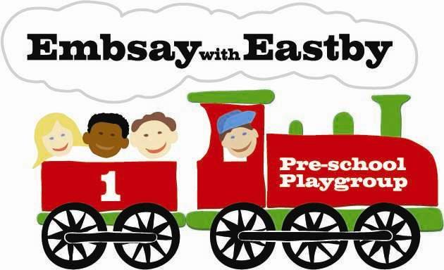
Speak Up!

Whistleblowing Procedures
You’re protected by law if you report any of the following:
- a criminal offence, for example fraud
- someone’s health and safety is in danger
- risk or actual damage to the environment
- a miscarriage of justice
- the company is breaking the law, for example does not have the right insurance
- you believe someone is covering up wrongdoing
- sexual harassment
Where to Report To

Managers –  Mrs Judy Hirst or Ms Emma Bowers  Embsay with Eastby Pre-School  The Village Hall  Main Street, Embsay  Skipton, BD23 6RE  Tel: 01756 791123  Email: embsaypreschool@btinternet.com | Chair of Management Committee –  Mrs Victoria Hindmarch  Banks Farm House  Storiths  Skipton  BD23 6HU  Tel: 07514 875009  Vickiprocter92@gmail.com
Any other member of the Management Committee that you are comfortable to raise your concern with. (Refer to the noticeboard in Pre-school for contact details)
Raising concerns outside the setting
- If you feel the employer will cover it up, would treat you unfairly if you complain or hasn’t dealt with it appropriately, you can contact:
NSPCC  Whistleblowing Advice Line  0800 028 0285  8am – 8pm Monday to Friday  9am – 6pm Weekends  help@nspcc.org.uk  National Society for the Prevention of Cruelty to Children (NSPCC)  Weston House, 42 Curtain Road. London, EC2A 3NH | North Yorkshire Safeguarding Children Board  www.safeguardingchildren.co.uk  Search Whistleblowing for latest advice  Also referral forms for LADO  & Children’s Social Care
Ofsted
Piccadilly Gate, Store Street
Manchester, M1 2WD
Ofsted Whistleblowing Hotline: 0300 123 3155
Email: whistleblowing@ofsted.gov.uk
Website:
https://www.gov.uk/government/organisations/ofsted/about/complaints-procedure

Protect – Speak up stop harm
Tel: 020 3117 2520
Website: www.protect-advice.org.uk

General guidance
https://www.gov.uk/whistleblowing
Registered Charity No. 1036590

