Embsay with Eastby Pre-School Playgroup
and Out of School Club

Early Years Practice Policy
Prime times – Sleep and rest time

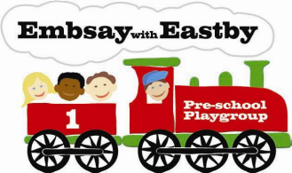

Sleep and rest times are key times in the day for being close and promoting security. Younger children will need to sleep but older children do not usually need to. No child is made to sleep.
- Children sleep on rest mats and have their own bedding which is kept in a personal box.
- Nappies are changed (or children are encouraged to go to the toilet) and heavier clothing removed.
- The back room is made quiet, with lights out and perhaps with soft music playing.
- Children are settled by their key person, where possible, and comforted to sleep if needed. Key persons may gently stroke or pat children.
- If children fall asleep in-situ it is necessary to move or wake them to make sure they are comfortable, they are not left to sleep other than on a sleep mat on the floor, unless exceptional circumstances.
- Sleeping children are regularly checked at least every ten minutes and are within sight and/or hearing of staff. This is recorded with the time checked, the position of the child and the initials of the person responsible for checking in the ‘Sleep Book’.
|
Further guidance
Safer Sleep for Babies (Lullaby Trust) www.lullabytrust.org.uk/safer-sleep-advice

This policy was reviewed in August 2025 and adopted at a meeting of the Playgroup Management

Committee held on 16th September 2025

……………………………………………………………… signed on behalf of the Playgroup Management Committee

Position held: Chair of Management Committee

To be Reviewed: May 2026

